2013 The year to shift focus
By Michael Witts, ING DIRECT Treasurer

2012 will be remembered as the year in which the Australian economy stood tall while the global economy crumbled around it. But as with all good things the party eventually comes to an end. The key to a good party is not so much the party itself but how you wake up the next morning.

The Australian economy is at a critical phase; the response to which will influence how it performs and transforms as the investment phase of the resources boom winds down over the next one to two years.

2013 will be the year in which the RBA will attempt to shift the focus of economic growth from the slowing resources related sectors to the interest rate sensitive sectors of the economy. Against this background we now expect the RBA to persist with a neutral to accommodative monetary policy stance in the period ahead. Inflation is expected to remain modest which will support the RBA sitting tight for an extended period. The risk is that rates may be slightly lower than what we are currently forecasting.

This article reviews the various drivers of Australia’s growth over the past year and the likely direction of these in the year ahead.

International Factors

The US economy continues to exhibit increasing signs that the recovery is becoming more broadly based.

The key issue for the US economy has been the resolution of the so called “fiscal cliff”. While the immediate issue has been overcome significant further work needs to be completed before this issue can be put behind markets.

The US Federal Reserve appears likely to persist with their accommodative policy stance for the foreseeable future.

Against this background the leadership transition has added significance, as the Chinese economy will remain the growth engine for Asia and the broader global economy.

Reflecting deliberate policy action by the Chinese authorities, the growth rate in the economy has slowed. Taken in combination with the European induced slowdown in export demand, the challenge for the new leadership will be to engender domestic sources of growth to insulate the economy from external influences. This policy stance has been effective over recent quarters and is expected to continue into calendar 2013.

The Chinese economy has doubled in size in the past 8 years; therefore it is reasonable to expect some retracement from the 10% growth rates experienced during the middle years of the past decade.

The ongoing urbanisation of China and increasing standard of living will underpin growth and sustain demand over the medium term. While there may be temporary setbacks from time to time the underlying trend will remain intact.

In contrast to the outlook for the Chinese and Asian economies, European economies are expected to continue to struggle with the negative impact of various austerity programs, while trying to promote growth and economic adjustment to avoid social unrest due to stubbornly high unemployment levels. This will not be easy and will test the resolve of governments which are subject to fast approaching election cycles.

Although Europe has many hurdles ahead, it appears the potentially most destructive aspects have been overcome to date. However, it is becoming an increasing challenge to plaster over each new emerging crack in the structure.

This outlook suggests Europe will remain a considerable drag on global growth over the forecast period and potentially well beyond. European interest rates will remain at current very low levels for an extended period.

Commodity prices

Softer commodity prices over the second half of 2012 made headlines, heralding the end of the resources boom.

Yes commodity prices have eased as slower global growth has taken its toll. However, taken in context, commodity prices are still well above recent average levels.

Despite the European outlook, the combined picture that emerges for the US and Chinese economies suggest that commodity prices will remain well supported in the period ahead.

The easier tone in commodity prices has been cited as contributing to the delay/postponement of a number of investment projects. While undoubtedly this will have an impact on new investment activity, the increased production and higher export volumes as past investment projects is often overlooked. Therefore, while investment spending may be lower, export income will be underpinned as the investment boom moves from the investment phase to the production phase.
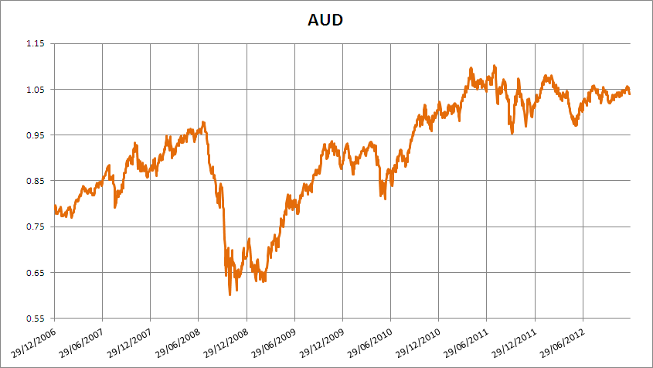

Domestic Activity

The domestic economy, in aggregate, has continued to outperform the majority of world economies over the past 12 months.

The overall picture masks the pockets of weakness in key sectors of the economy.

In particular, non-resource related export competing sectors have been adversely impacted by the high value of the Australian dollar. In addition, construction activity across both residential and commercial sectors has been subdued.

The RBA is using lower interest rates to boost these sectors of the economy.

The combination of the low mortgage rates and a solid employment market has seen slow improvements coming through the owner occupied segment of the market. Interestingly, it appears that investors are starting to return to the market with this segment up over 10% on an annual basis. Meanwhile, commercial activity is still operating from a low basis as credit remains expensive despite lower absolute rates.

In many ways it almost appears as the RBA is attempting to repeat the performance in the 10 years from the mid 1990’s. As noted in a recent speech from the RBA commenting on this period

“Lower nominal interest rates gave households increased access to debt, with many households taking advantage of this. This pushed up the price of housing and some households used their increased equity to fund higher consumption. Financial liberalisation and rising house prices were also associated with greater turnover in the property market. These developments also helped generate strong employment growth. This boosted fiscal revenues, as did the large increase in the terms of trade and this boost to revenues made possible frequent cuts in personal income taxes”

This time around the RBA will be mindful of not promoting property asset inflation.

Equally, the RBA has stressed the importance of the need to address the relatively poor performance by the Australian economy in terms of productivity growth.

Monetary policy is shouldering more of the responsibility for economic growth in view of the restrictive fiscal policy stance. The recent announcement that the Government is moving away from its commitment of a balanced budget is to be welcomed. The adherence to a dogma, in light of changing domestic and global economic picture could have potentially generated an adverse outcome for the economy. In addition, lower interest rates are seen as a potential tool to lower the exchange rate.

While this is usually effective, the current global economic picture has resulted in strong performing countries who largely avoided the GFC, confronting an almost unique combination of lower interest rates and higher exchange rates. This is driven by global funds seeking secure investments in an increasingly uncertain global environment. This, in combination with Australia’s still comparatively high interest rates suggests further downward adjustment in domestic rates is possible in the year ahead.

In context, global interest rates are broadly at or around zero across the majority of major economies, with very little prospect of any meaningful increases. Despite the decreases over 2012, interest rates in Australia remain elevated in global terms.

Inflation Outlook

The various measures of inflation are all at levels that do not present a risk for the RBA. On this basis, inflation will not be an impediment to further action, if needed, by the Bank.
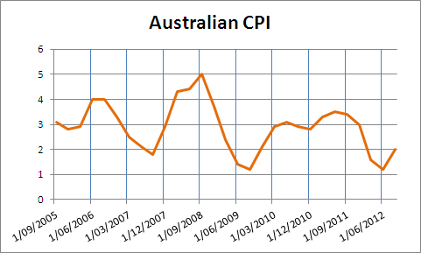

Labour productivity is emerging as the key issue for the economy over the near to medium term. Productivity growth is an effective tool to manage the increase in labour costs and restore the competitive position of Australian industry notwithstanding the high exchange rate.

Interest Rate Outlook

It appears likely that interest rates will be steady to slightly lower over 2013.

Previously it appeared likely that further significant interest rates reductions were in prospect, however, with the government announcement that fiscal policy will be somewhat easier than previously anticipated, the RBA may not cuts rates as much.

Current market expectations are for one further rate cut and the outside possibility of a second rate cut later in 2013. As always, the global environment will exercise a significant influence on the setting of domestic interest rates.

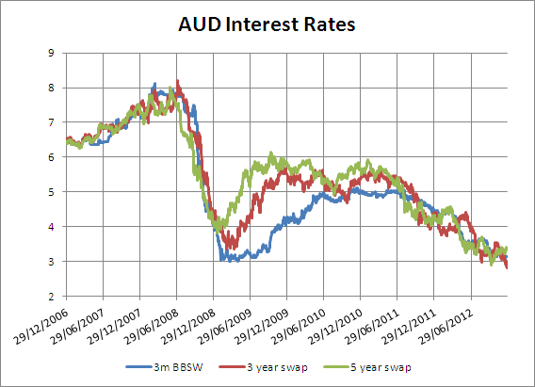

Borrowers will draw comfort in the knowledge that it is highly unlikely that interest rates will be higher in the year, with the very real prospect of lower rates.

Conversely, for investors the neutral interest rate environment will be disappointing, however, the competition for retail deposits appears likely to continue and will provide a partial cushion for fixed income investors.

