MEDIA RELEASE

Australians pay an average $2,000 in super fees each year
Fees slash the value of retirement incomes – up to 19%¹

Wednesday, 20 February 2013: Australians are paying an average of $2,000 on superannuation fees each year, with older Australians paying as much as $6,000, according to new research. To highlight this, ING DIRECT has created a giant human billboard forming the $20 billion total paid in 2012.

ING DIRECT’s Head of Superannuation, Michael Christofides said, “Too many Australians are getting ripped off when it comes to the fees they’re paying on superannuation.

"Whether you're a member of a retail fund or an industry fund, you could well be paying more than you think."
Age | Average Super balance | Average annual fee
Under 35 | $30,512 | $445
35-49 | $93,073 | $1,239
50-59 | $252,349 | $3,262
60-65 | $285,422 | $3,682
65+ | $478,160 | $6,130

The research by Rainmaker, commissioned by ING DIRECT, shows how much fees are reducing retirement incomes, for example:

Impact of fees during working life:
- Someone retiring at 67, who commenced work at 20, could pay as much as $174,000 in super fees depending on which fund they are in. ²

Impact of fees during retirement:
- Someone retiring at 65 with a balance of $500,000 would pay up to 19% of their cumulative benefits in fees over 35 years. ³

The Rainmaker research has also shown Australians are paying on average 1.26% per annum in fees and personal funds charge the most – 2.01% p.a. per member.

Fund type | Average annual fee
Personal Funds | 2.01%
Retirement Funds (e.g. Pension funds) | 1.84%
Workplace Funds (e.g. Corporate and Employer sponsored funds) | 1.38%
SMSFs | 0.87%
Not-for-Profit Funds (e.g. Industry Funds) | 0.97%

“Consumers have the right to be frustrated at paying such large fees, particularly when the research shows there is no correlation between fees and performance,” said Christofides.

Last year, ING DIRECT launched Living Super - the first balanced fund for all Australians with no admin or management fees. The fund is made up of 50% cash and 50% shares.

-ENDS-
1. RESEARCH – DETAILS
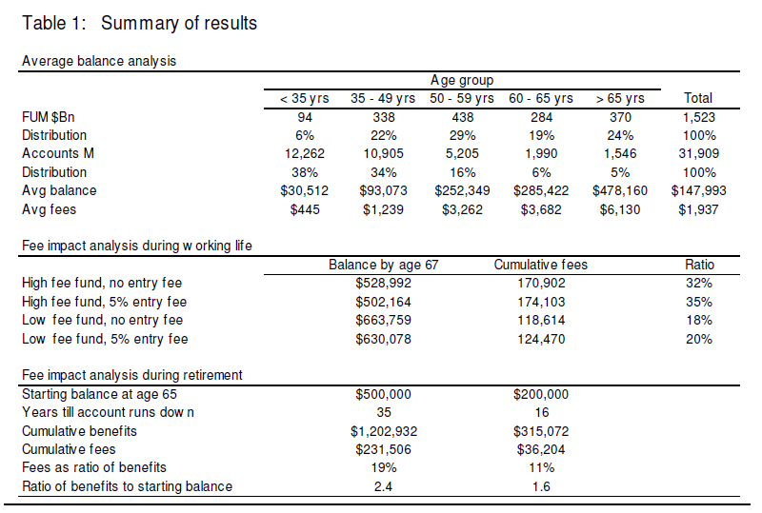

2. Based on an individual commencing work at age 20 with an annual salary of $25,000 contributing the current standard 9% SG and receiving annual investment earnings of 6% per annum net of tax.

3. Based on annual post tax earnings of 7%, an income stream benefit midway between the legislated minimum annual payment and the ASFA retirement living annual benchmark for a moderate lifestyle, and paying standard fees according to Rainmaker benchmarks for retirement products.

Buy/Sell spreads and other incidental transaction costs apply to all managed investment options, including the Balanced fund. Buy/Sell spreads and other transaction costs are retained within the managed investment and are not fees paid to ING DIRECT or the Trustee. The Trustee may replace one or more of the underlying investment managers which may affect the fee structure for the investment options. The Trustee may vary the fees for ING DIRECT Living Super without your consent by giving 30 days notice.The Trust Company (Superannuation) Limited ABN 49 006 421 638, AFSL 235153, RSE L0000635, is the Trustee of the ING DIRECT Superannuation Fund ABN 13 355 603 448 (Fund) and the issuer of interests in the Fund. ING DIRECT Living Super is a product issued out of the Fund. ING DIRECT, a division of ING Bank (Australia) Limited ABN 24 000 893 292, AFSL 229823, is the Promoter of the Fund and the issuer of this document. Eligibility criteria for ING DIRECT Living Super apply. Any advice provided does not take into account your objectives, financial situation or needs and you should consider whether it is appropriate for you. You should consider the Product Disclosure Statement available at ingdirect.com.au when deciding whether to acquire, or to continue to hold the product.
The source for the statement ‘The first Balanced fund for all Australians with no administration or management fees’ is SuperRatings Fee Research April 2012. This research included information about the default options of 372 currently available and closed superannuation funds. The accuracy of the information relied on by SuperRatings was the responsibility of the trustees of the relevant superannuation funds.
The information in this release is based on the research conducted by Rainmaker Information Pty Limited ABN 86 095 610 996 contained in the Rainmaker Superannuation Fee Impact Analysis prepared for ING DIRECT in February 2013, the Rainmaker 2012 Super fund fee Survey March 2012 Edition and research released in October 2012 that states that super fund members paid an estimated $20.1 billion in super fees in the 2011/12 financial year.

For photos and video of the event, visit the ING DIRECT Online Newsroom.

Media contact:
Caroline Thomas
PR Manager, ING DIRECT
+61 2 9018 5160
+61 413 317 225
caroline.thomas@ingdirect.com.au

About ING DIRECT
ING DIRECT pioneered branchless banking in Australia by offering the first online, high interest, fee free savings account. Our low cost operating model allows us to pass these savings on to the customer in the form of great value products and services. Today, ING DIRECT has more than 1.4 million customers with $26 billion in deposits and $38 billion in mortgages and a range of innovative products. Please note ING DIRECT is never abbreviated to ING.

