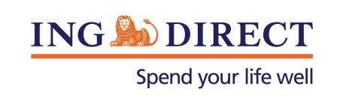
Media Release

ING DIRECT Bushfire response

Wednesday 23 October 2013: As a result of the recent bushfire crisis in parts of NSW, ING DIRECT has a range of relief measures available for affected customers.

Home Loan customers who have been impacted by the fires will be offered a range of options to assist with mortgage repayments, including hardship assistance and waiving fees involved with restructuring loans.

Affected Savings Clients will be given fast release of funds (SWIFT) to clients’ linked bank accounts and no early termination penalty for Term Deposits.

Standard card replacement, emergency cash and goodwill payments for dishonour fees for failed direct debits is available for affected Orange Everyday customers.

ING DIRECT will be making two donations to help local communities through the crisis and rebuild for the future.

$50,000 will be donated to the Red Cross Disaster Relief & Recovery and a further $50,000 to the Foundation for Rural & Regional Renewal – which work with communities to build their capacity for long term sustainability following natural disasters & stimulate renewal.

-ENDS-

Media contact:
Caroline Thomas
PR Manager, ING DIRECT
+61 2 9018 5160
+61 413 317 225
caroline.thomas@ingdirect.com.au

About ING DIRECT
ING DIRECT pioneered branchless banking in Australia by offering the first online, high interest, fee free savings account. Our low cost operating model allows us to pass these savings on to the customer in the form of great value products and services. Today, ING DIRECT has more than 1.4 million customers with $30 billion in deposits and $38 billion in mortgages and a range of products including transaction accounts and superannuation. Please note ING DIRECT is never abbreviated to ING.

