 | 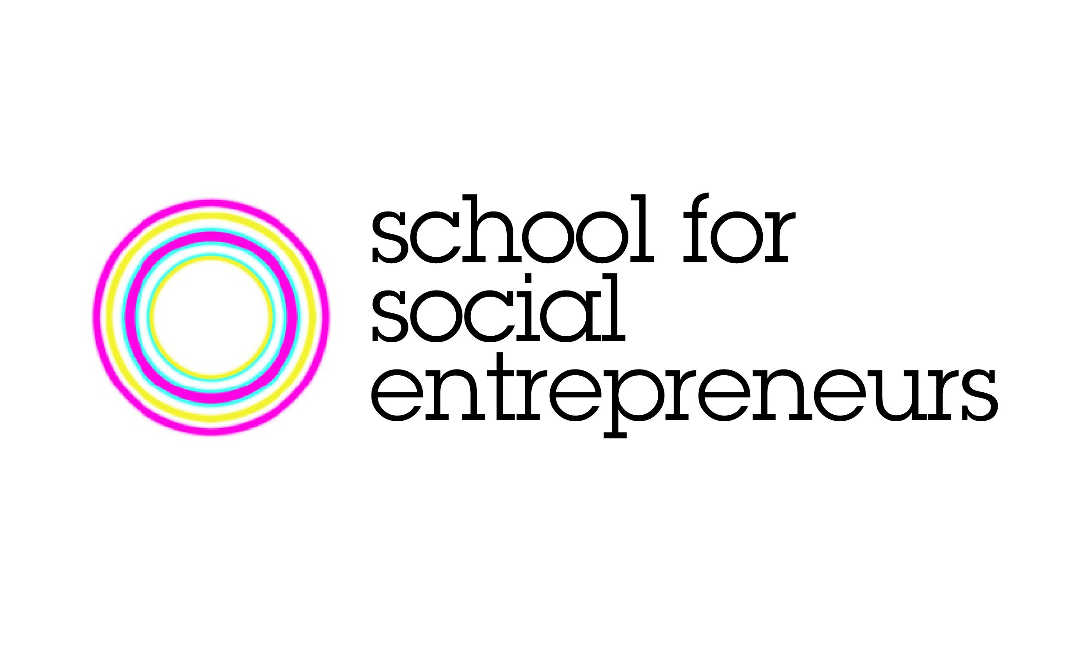 | 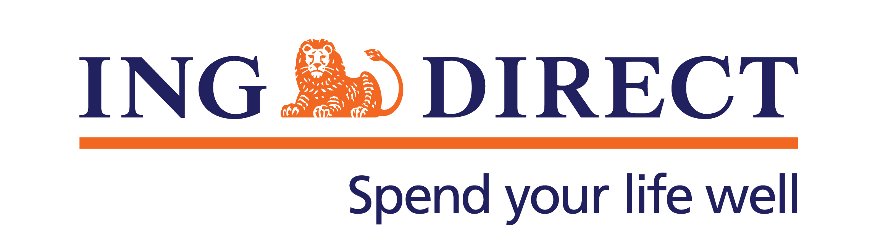
StartSomeGood and ING DIRECT launch Dreamstarter: A crowdfunding platform for social entrepreneurs
StartSomeGood has partnered with leading financial services provider ING DIRECT to launch Dreamstarter, a crowdfunding initiative to boost Australia's social enterprise sector.
Dreamstarter offers inspirational Australian entrepreneurs an online platform to raise funds towards diverse social change projects. Successful projects that capture the imagination and support of the community will receive additional funding from ING Direct.
StartSomeGood cofounder Tom Dawkins said the partnership breaks new ground in the corporate social responsibility (CSR) sector.
“Crowdfunding is a participatory model that democratises corporate philanthropy. The projects that will succeed are those that have a genuine mandate from the community,” said Dawkins.
As the pioneer of branchless banking in Australia, ING DIRECT’s focus on online delivery and social media offers clear synergies with the crowdfunding model.
“At ING DIRECT we strongly support innovative projects that address real community needs,” said Vaughn Richtor, ING DIRECT CEO. “Leveraging ING DIRECT’s customers, employees and the general public’s support benefits all involved.”
Ten ventures by social entrepreneurs that graduated from the School for Social Entrepreneurs Australia will launch in the initial round of fundraising through the Dreamstarter platform. The first enterprises to go live include a project to connect remote Aboriginal entrepreneurs to new markets via an online store (Enterprise Learning Australia) and an initiative to help rural communities in Malawi to achieve greater self-sufficiency (Empower).
The CEO of the School for Social Entrepreneurs Celia Hodson sees innovative crowdfunding collaborations like Dreamstarter as breaking down many of the traditional barriers social entrepreneurs face when attracting support for their ventures.
“The Dreamstarter Campaign is a fantastic way for start up social ventures to raise their profile, attract critical seed funding and inspire others to create change in their communities,” said Hodson.
People can apply to be a part of the Dreamstarter program, or find more information, at www.ingdirect.com.au/dreamstarter

Interview opportunities and high resolution photographs are available for the Dreamstarter candidate entrepreneurs as well as representatives of StartSomeGood, ING DIRECT and the School for Social Entrepreneurs.

Media Contacts:
Karen Gould  Communications Manager  StartSomeGood  0413 282 361  karen@startsomegood.com | Fleur Townley  ING DIRECT  0405 278 758  fleur.townley@ingdirect.com.au | Sally McGeoch  School for Social Entrepreneurs Australia  0438 153 655  sally@sse.org.au

About StartSomeGood
StartSomeGood is a crowdfunding platform for social innovation. We aim to create an "everyone a changemaker" world, where anyone with an idea for creating a better future is empowered to make it happen. We connect your dream with the people and resources you need to make an impact.
About the School for Social Entrepreneurs
The School for Social Entrepreneurs (SSE) Australia runs practical learning programs for entrepreneurial individuals who have an idea or start-up venture with a social or environmental benefit. Since launching in 2009, SSE Australia has supported the development and networked close to 200 social entrepreneurs across Australia. The initial round of Dreamstarter applicants are all graduates of the School for Social Entrepreneurs in Australia.
About ING DIRECT
ING DIRECT pioneered branchless banking in Australia by offering the first online, high interest, fee free savings account. Our low cost operating model allows us to pass these savings on to the customer in the form of great value products and services. Today, ING DIRECT has more than 1.4 million customers with $26 billion in deposits and $38 billion in mortgages and a range of innovative banking products.
Please note ING DIRECT is never abbreviated to ING.

