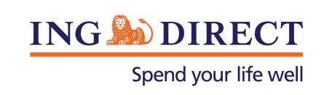
Media Release

Lisa Claes a finalist for Telstra Business Women’s Awards

30 September 2013: Developing the country’s first straight through online application process embedding electronic verification and successfully leading ING DIRECT’s various business units through times of change, has contributed to Lisa Claes’ dual finalist nominations in the 2013 Telstra Business Women’s Awards.

Claes, a finalist both the Corporate and Public Sector Award categories will vie for the NSW Award before becoming eligible for the National category award in November.

Claes says she is thrilled to be recognised as a finalist given the calibre of her fellow entrants.

“The achievements of these women is nothing short of amazing, I feel privileged to be surrounded by such inspiring people,” said Claes.

A career achievement which also put Claes in the Business Innovation category was her work to create an electronic customer verification process which negated the need for paper forms and face to face ID checks, thus improving the customer experience – a benchmark created for the entire banking industry.

Claes’ entry also highlighted her role as a leader within the mortgage and financial planning industry as well as her work with ING DIRECT’s various community initiatives which focus on improving education and career prospects for young Australians.

-ENDS-

Media contact:
David Breen
Head of Corporate Affairs
ING DIRECT
Ph: 0412 933 060
E: david.breen@ingdirect.com.au

About ING DIRECT
ING DIRECT pioneered branchless banking in Australia by offering the first online, high interest, fee free savings account. Our low cost operating model allows us to pass these savings on to the customer in the form of great value products and services. Today, ING DIRECT has more than 1.4 million customers with $30 billion in deposits and $38 billion in mortgages and a range of products including transaction accounts and superannuation. Please note ING DIRECT is never abbreviated to ING.

