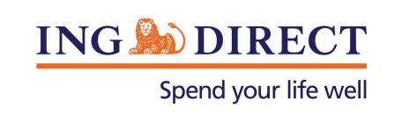
Media Release
True mortgage innovation comes with customer focus

Wednesday, 2 April 2014: The future of the mortgage and broking industry hinges on its ability to deliver customer focused products and services through multiple channels, according to ING DIRECT Executive Director of Distribution Lisa Claes.
Speaking at the AB&F Mortgage Innovation Forum, Ms Claes said banks and brokers will need to provide more value and expanded access to multiple service providers to support customers.
“People are excited and engaged about buying a home not about getting a mortgage.”
Ms Claes believes banks and brokers can add more value by increasing the speed, convenience, accuracy and reliability of the mortgage process.
“The added value of these attributes will increase the “feel good” factor of buying a home which should be an enjoyable process.”
Ms Claes used examples from Germany, Spain and the Netherlands to show international best practice in mortgage innovation.*
Ms Claes says successful mortgage innovators of the future will keep close to customers throughout the entire life cycle of their home loans.
“Those that have meaningful digital dialogues with their customers will be in the best position to add value for the life of the home loan. This will present greater opportunity to work with customers to help build their financial future.”
Ms Claes says banks and brokers in the future will need to facilitate the increasingly self directed customer, integrate distribution touch points and provide customers with wealth creation support rather than simply transacting a mortgage.
* Full copy of presentation available on request
-ENDS-
Media contact:
Caroline Thomas
PR Manager, ING DIRECT
+61 2 9018 5160
+61 413 317 225
caroline.thomas@ingdirect.com.au

About ING DIRECT
ING DIRECT changed the way Australians bank 15 years ago by launching the country's first high interest, fee free online savings account. Since then, we’ve brought this low fee value to home loans, transactional banking and superannuation. With over 1.5 million customers – and $30 billion in savings and $38 billion in mortgages – ING DIRECT has the highest reputation of any other bank in Australia (RepTrak, Oct 2013), as well as the highest Net Promoter Score (NFSM, December 2013).

