Media Release:
Household savings triple in just two years
Low interest rates have failed to dampen enthusiasm for cash deposits as median household savings rise to $15,427 in Q1 2013 up from $5,155 in mid-2011.

Wednesday, 24 April 2013: The ING DIRECT Financial Wellbeing Index confirms that the efforts of Australian households to reduce debt are paying off. With 93% of home owners saying they are ‘comfortable’ about their mortgage, households are now focusing on building savings.

Australian households currently have median savings of $15,427 - the highest since tracking began in Q1 2010. This represents significant savings growth since mid-2011 when the Index recorded a low point for savings of $5,155 per household.

Key findings for Q1 2013 (surveyed in April 2013):
- Financial wellbeing with mortgages is on a clear upward trend. 93%of home owners are ‘comfortable’ with their mortgage - 65% are ‘very’ comfortable.
- 71% of households are comfortable with their level of savings.
- Household savings are lowest for Gen X households (aged 35-49) with a median of $8,060 compared to $14,377 for Gen Y (18-34) and $17,744 for baby boomers (50-64).
- In Q1 2013, 13% of Australian households report having zero savings - the lowest since inception of the Index.

Household confidence rises
The quarterly Financial Wellbeing Index rates household comfort levels across six key aspects of personal financial wellbeing including credit card and mortgage debt, savings, investments, household income and ability to pay bills.

The ING DIRECT Financial Wellbeing Index rises to 108.2 in Q1 2013 up from 107.4 in Q4 2012.

The Q1 2013 Index reading of 108.2 is holding near the two year high of 109.0 reached on Q3 2012. Comfort levels across five out of six financial dimensions increased in Q1 2013, the only exception is confidence in long term assets and investments, which fell slightly over the quarter to a score of 3.5 (out of a possible 7) down from 3.6 in Q4 2012.

Mortgage proves no barrier to saving
Australians are taking advantage of low interest rates to pay down their mortgage. In Q1 2013 44% of home owners were ahead with their loan, and comfort with long term debt now has the strongest rating across all six financial indicators – with a score of 5.7 out of a possible 7.

Low interest rates are not discouraging households from building cash deposits. Since mid-2011 when a low point of median savings ($5155) was recorded, households have steadily increased cash savings to the present household median of $15,427 – a three-fold increase in less than two years.

Paying off a mortgage is proving no barrier to building savings. Eight out of ten (84%) households with savings of $67,000 or more are home owners; 47% of those with less than $1,675 in savings rent the home they live in.

Gen X households – those most likely to be raising children, are finding it harder to build savings. One in three (31%) report having savings below $1,675 compared to 21% of Gen Y households and 21% of boomers.

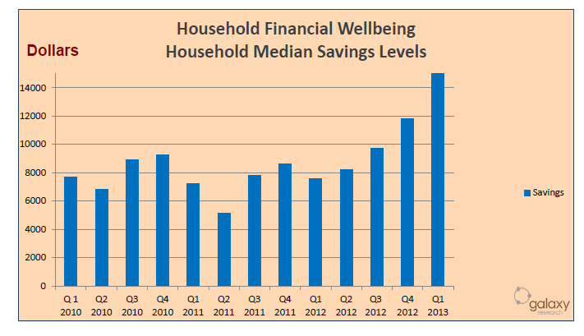

John Arnott, Executive Director Customer at ING DIRECT, says, “It is significant that household savings rose during the first quarter of the year as this is traditionally a time when many Australians experience a cash drain following the festive season.”

“The continued growth in savings since mid-2011 reflects the commitment of Australians to building a buffer of cash, and it is not surprising that high levels of savings are supporting increased financial confidence among households” added Arnott.

-ENDS-
For a copy of the full Report, go to the ING DIRECT Online Newsroom.
Media contact:
Caroline Thomas
Ph: 02 9018 5160
M: 0413 317 225
caroline.thomas@ingdirect.com.au

Research methodology
The ING DIRECT Financial Wellbeing Index was complied by Galaxy Research from the online responses of 1,059 households between 4 April and 9 April 2013. The data was weighted by region and household size to reflect the Australian household population based on the 2006 census. The level of savings reported in the study is also calibrated to APRA national bank total deposits (households) to ensure accuracy of household savings levels.

About ING DIRECT
ING DIRECT began operating in Australia in 1999. By doing business online, over the phone and through intermediaries, ING DIRECT keeps it overheads low and passes the savings onto customers in the form of competitive rates. Today, it has grown to become Australia’s fifth largest retail bank, with $29 billion in deposits, more than $38 billion in loans and around 1.4 million customers.
Please note ING DIRECT is never abbreviated to ING.

