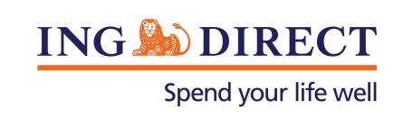
Media Release

ING DIRECT to decrease variable home loan rates by 0.25%

Tuesday, 7 May 2013: ING DIRECT will lower the interest rate on its variable mortgages by 0.25%, effective Friday 17 May 2013.

The RBA cash rate is one element considered however, the bank’s funding position was the driver of the decision.

Its most popular home loan the Mortgage Simplifier will be 5.47% p.a.

ING DIRECT is the fifth largest home lender in the country with $38 billion in mortgages.

-ENDS-

For high res images of Vaughn Richtor, visit the ING DIRECT Newsroom.

Media contact:
Caroline Thomas
PR Manager, ING DIRECT
+61 2 9018 5160
+61 413 317 225
caroline.thomas@ingdirect.com.au

About ING DIRECT
ING DIRECT pioneered branchless banking in Australia by offering the first online, high interest, fee free savings account. Our low cost operating model allows us to pass these savings on to the customer in the form of great value products and services. Today, ING DIRECT has more than 1.4 million customers with $30 billion in deposits and $38 billion in mortgages and a range of products including transaction accounts and superannuation. Please note ING DIRECT is never abbreviated to ING.

