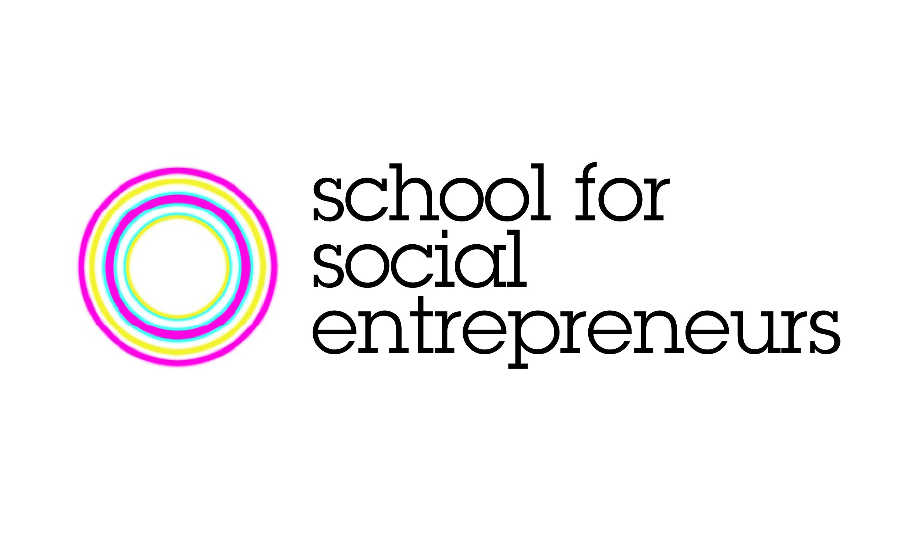

For Immediate Release:
March 4, 2013

New Program to Fast Track Sydney’s Social Enterprises

The School for Social Entrepreneurs Australia is calling for Sydney’s budding social entrepreneurs to sign up for its newest program designed for social and environmental ventures ready to launch or scale.

The 4-month Accelerator Program will provide a unique opportunity for up to 15 social entrepreneurs to work collaboratively with a talented team of facilitators, business experts and seasoned entrepreneurs to make their ventures effective and sustainable.

Unlike traditional educational and training programs, the School for Social Entrepreneurs (SSE) uses a “learning by doing” approach where students gain both practical business and personal skills that can be applied directly to their social or environmental enterprise.

The Accelerator Program is currently underway in Brisbane with student’s ventures ranging from an organic food delivery service to an e-waste recycling business that employs marginalised youth. One student (Helen Bird) has just launched her venture called Street Food Australia – a social enterprise which supports migrants and refugees to develop street food businesses using bespoke designed kitchens on cargo bikes.

The SSE Australia currently runs a range of programs from Sydney, Melbourne and Brisbane and boasts a Fellowship of close to 200 social entrepreneurs since launching in early 2009.
“We are really looking forward to working with our next crop of social entrepreneurs in Sydney and giving them the skills, confidence and networks to bring their enterprises to life,” said Celia Hodson, Chief Executive of SSE Australia.
The Sydney Accelerator Program which commences on May 27 is proudly supported by ING DIRECT and will bring key staff from the bank into the program to provide one-on-one expert support and mentoring to students.

“ING DIRECT is excited to be involved in this first Accelerator Program in Sydney as it provides a unique opportunity for our staff to work alongside passionate entrepreneurs to support the development of their bold and innovative social enterprises,” said Fleur Townley, Manager of Sustainability at ING DIRECT.

SSE defines social enterprises as businesses that trade to generate revenue and deliver a social or environmental benefit. Social entrepreneurs are the individuals who are behind the creation of social enterprises.

Visit www.sse.org.au to apply by April 8.

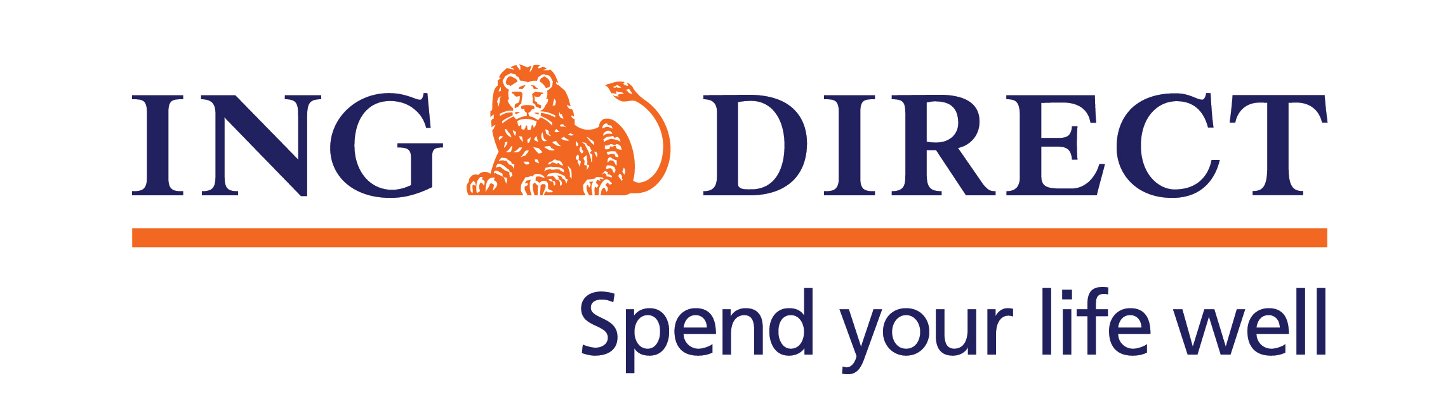
Media contact:
Sally McGeoch
sally@sse.org.au
0438 153 655
www.sse.org.au

